**ASSIGNMENT-3**

**ART GALLERY MANAGEMENT DATABASE MANAGEMENT SYSTEM**

**SUBMITTED BY**

-DEEKSHITHA R PES2UG19CS104

-DEEPA SHREE C V PES2UG19CS105

**Department of Computer Science and Engineering**

**PES UNIVERSITY**

**Triggers:**

1. **A trigger to ensure the salary of the employee is a valid number**

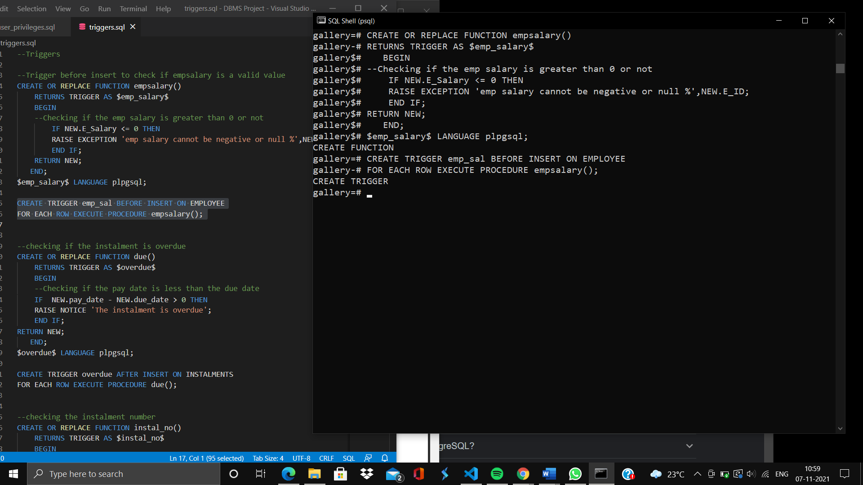

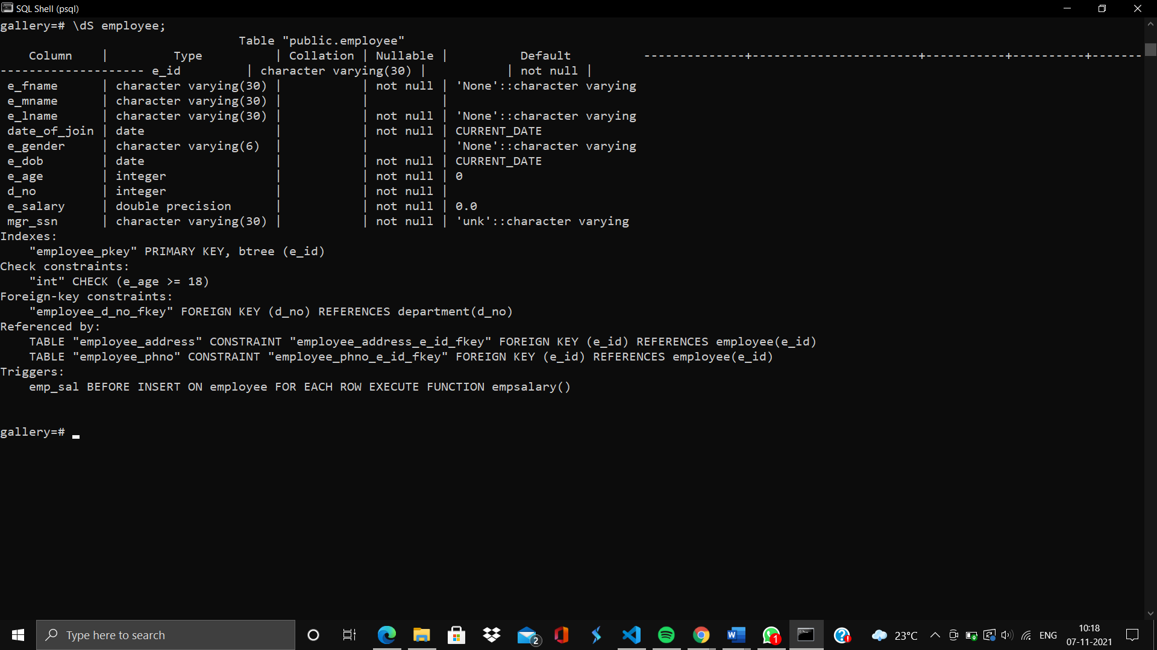

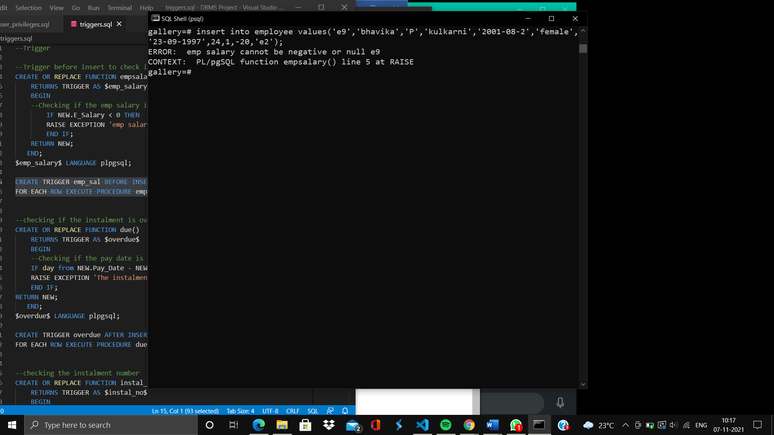**On inserting -20 as the salary, the trigger is aroused.**

1. **To raise a notice when the payment is overdue**

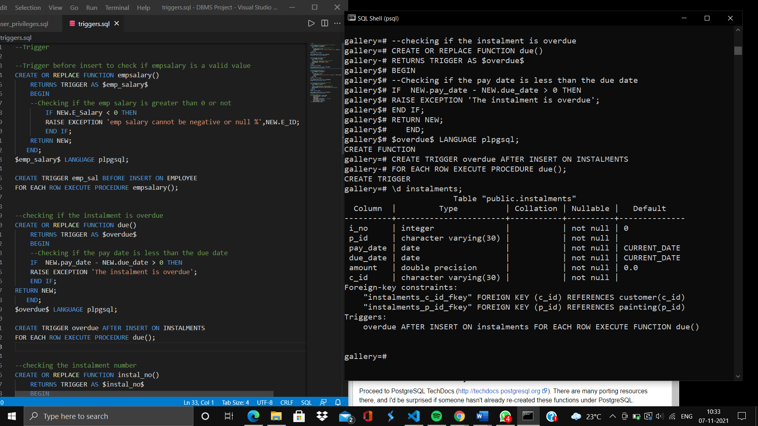

**A notice is raised when the due date is greater than the pay date**

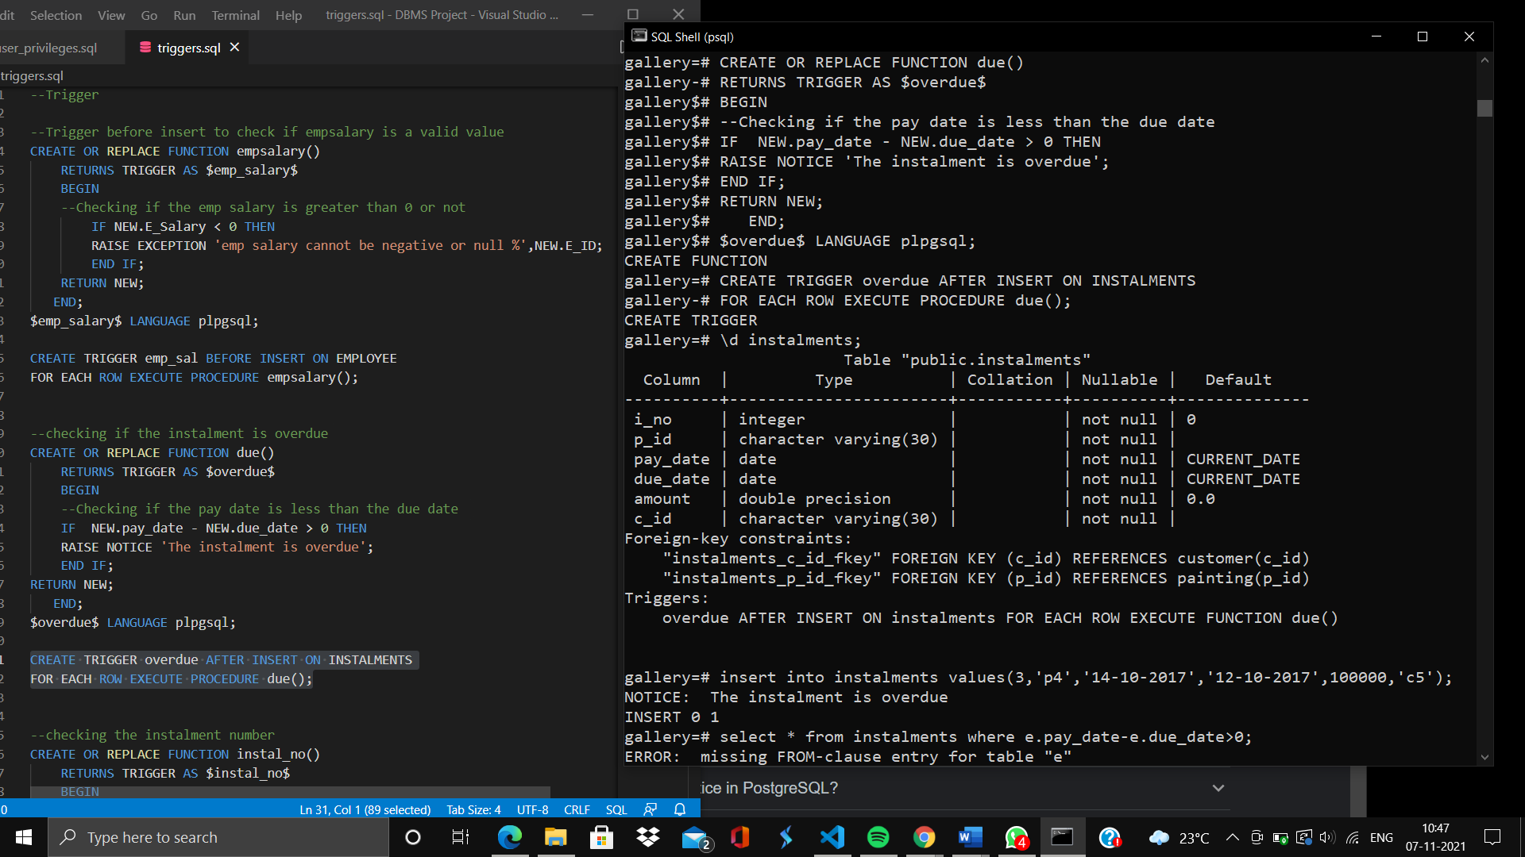

1. **To check the instalment number. It should always be less than or equal to 5.**

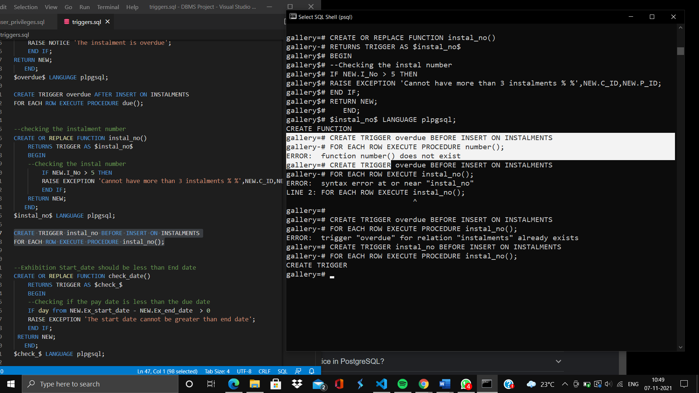



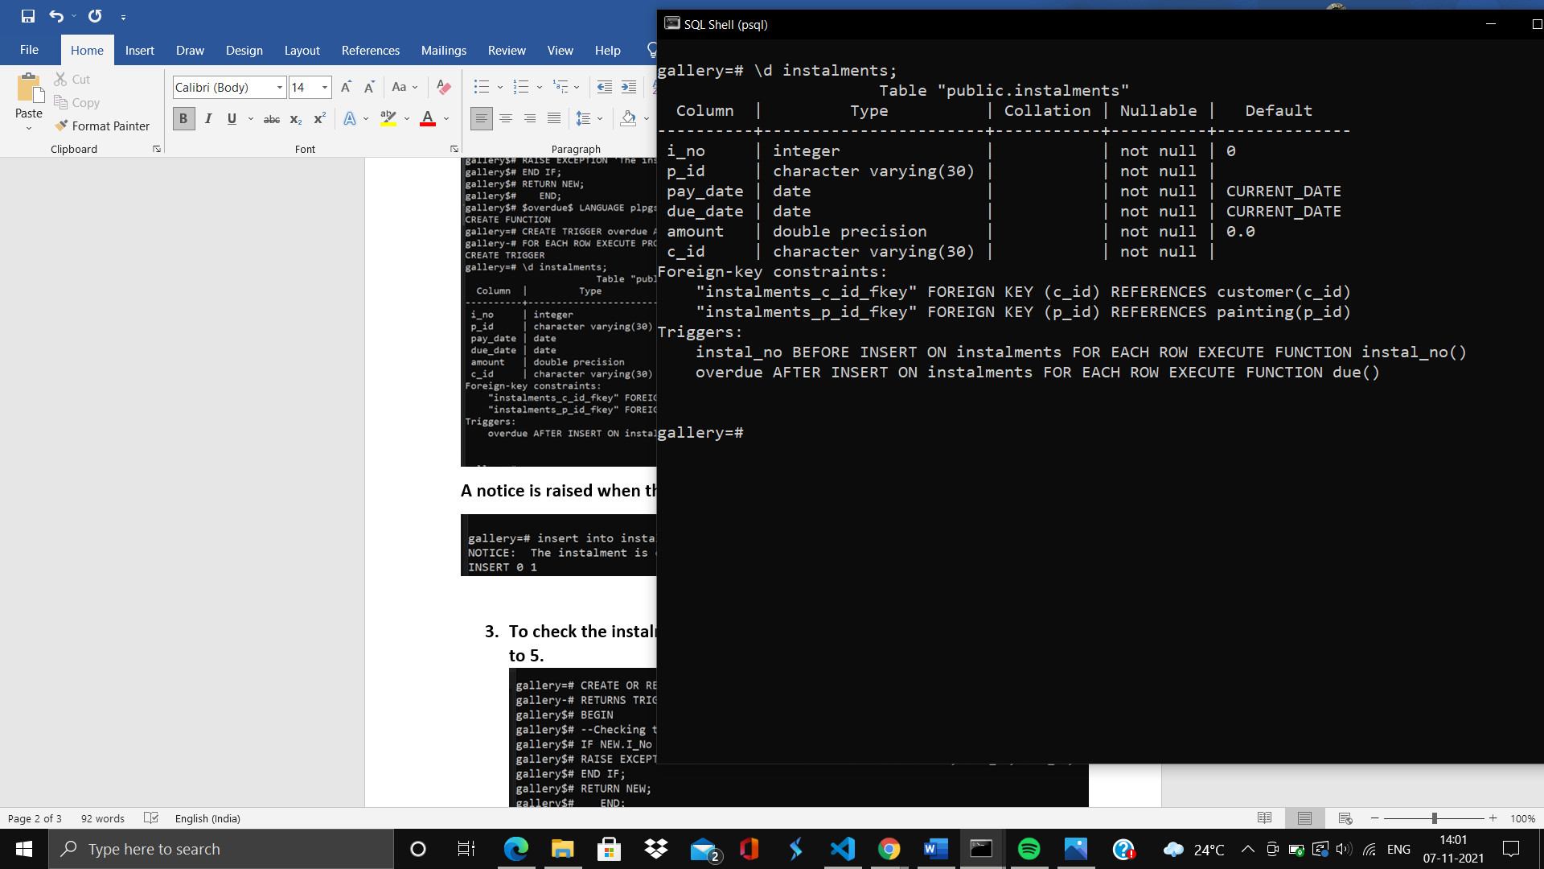

**An exception is raised when the instalment number is 7**

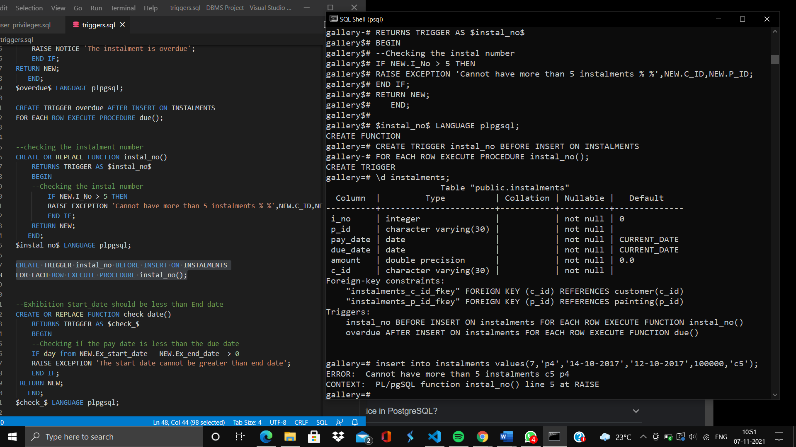

1. **A trigger to check the start date is less than the end date of the exhibition**

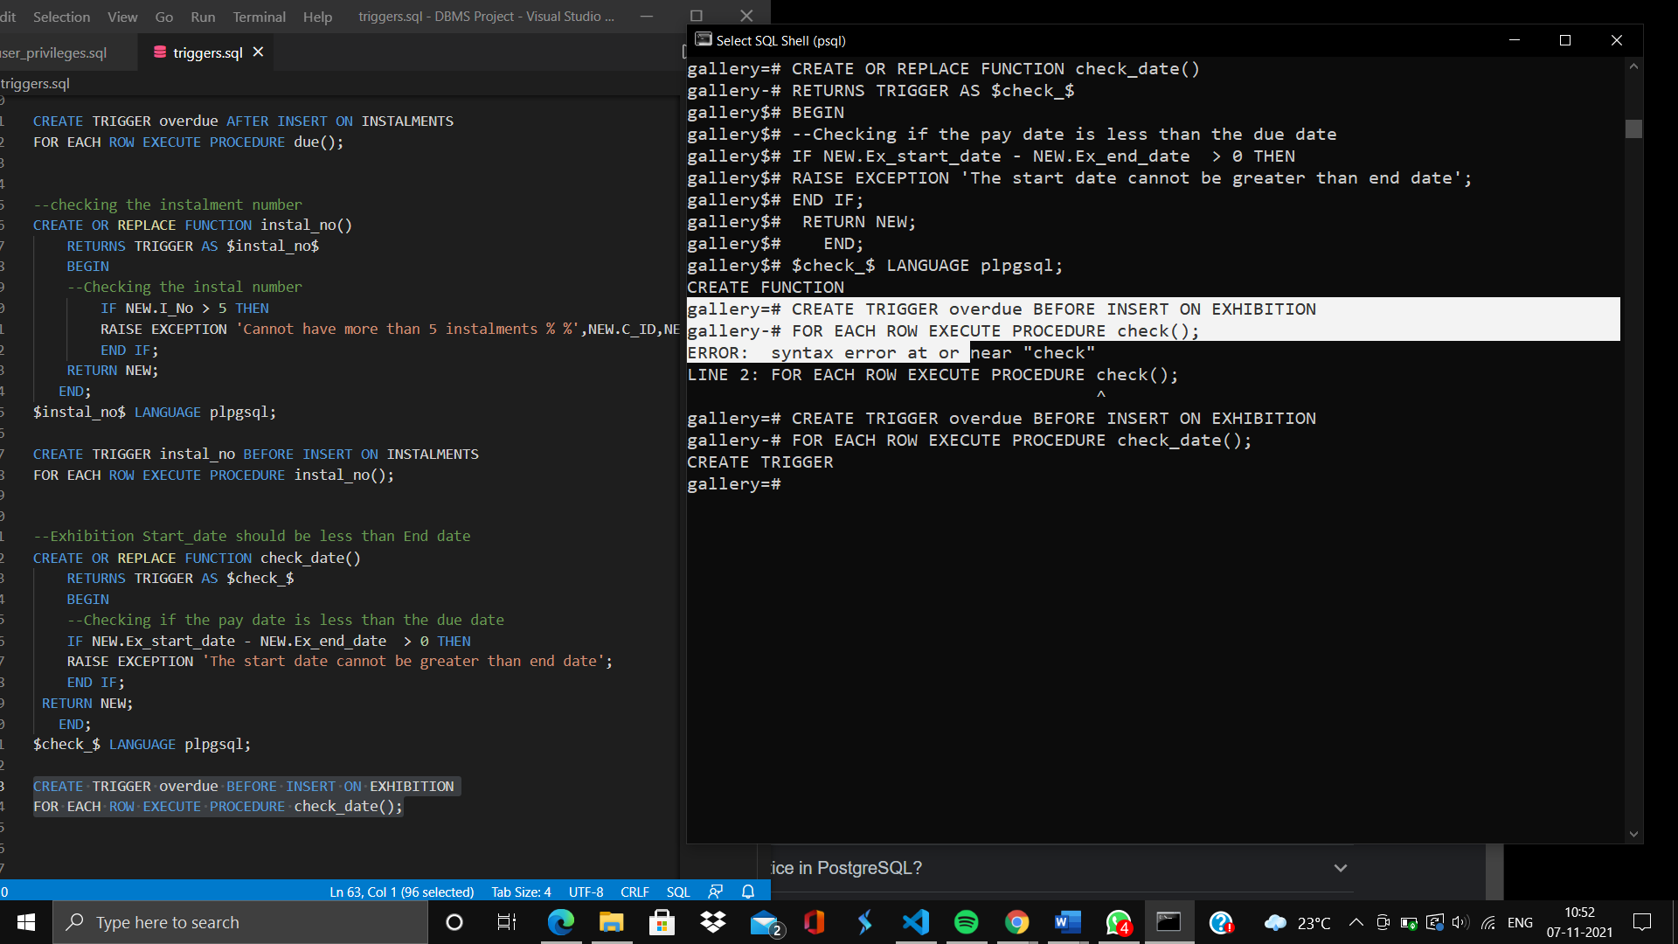

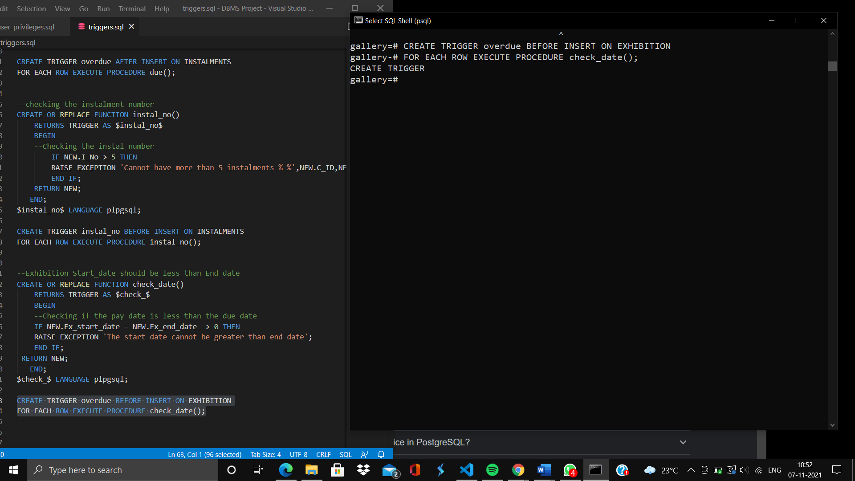

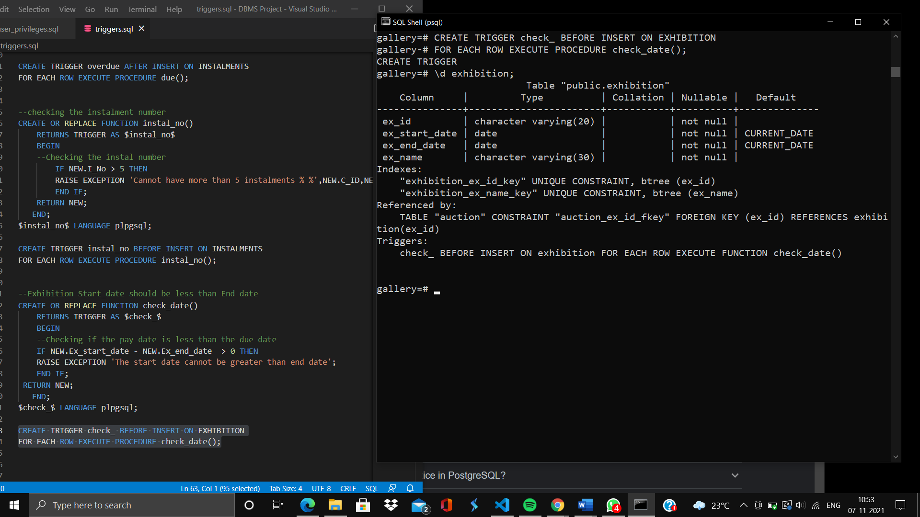

**An exception is raised on inserting a start date greater than end date**

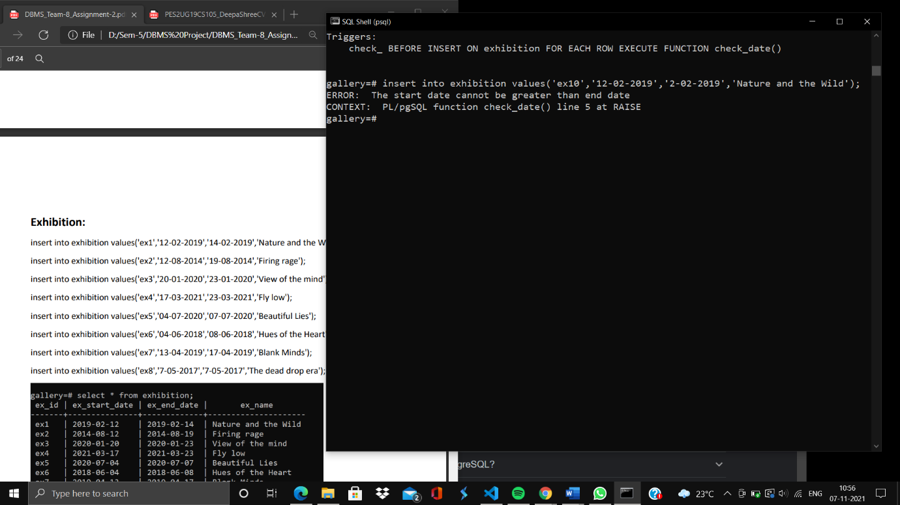

**A list of all the four triggers that are implemented.**

* overdue
* instal_no
* check_
* emp_sal

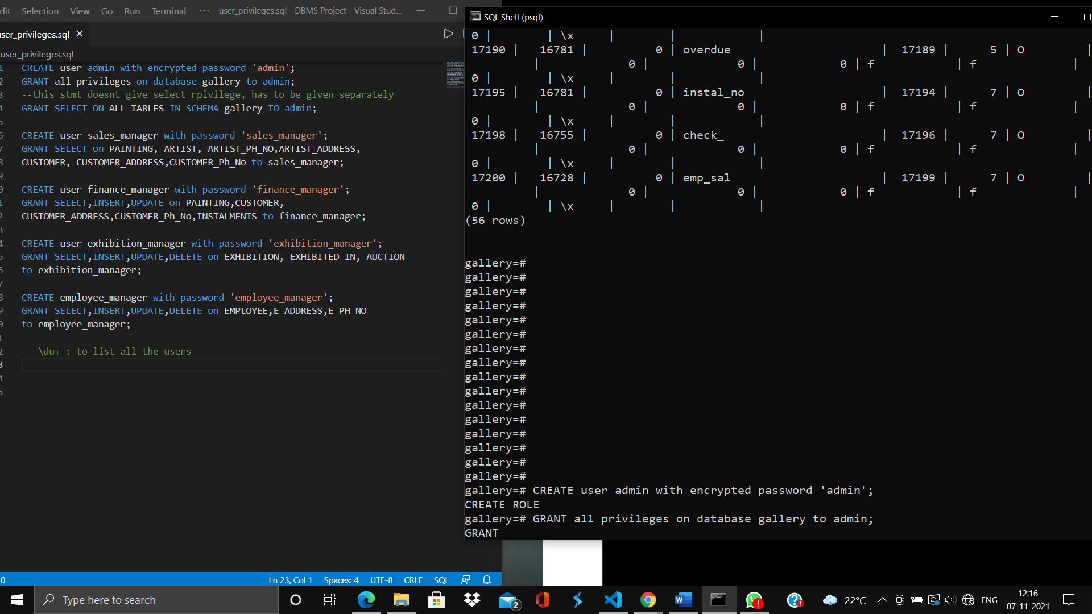

**Queries:**

1. **Obtain the last name and the email of all the customers who have bought at least one painting.**

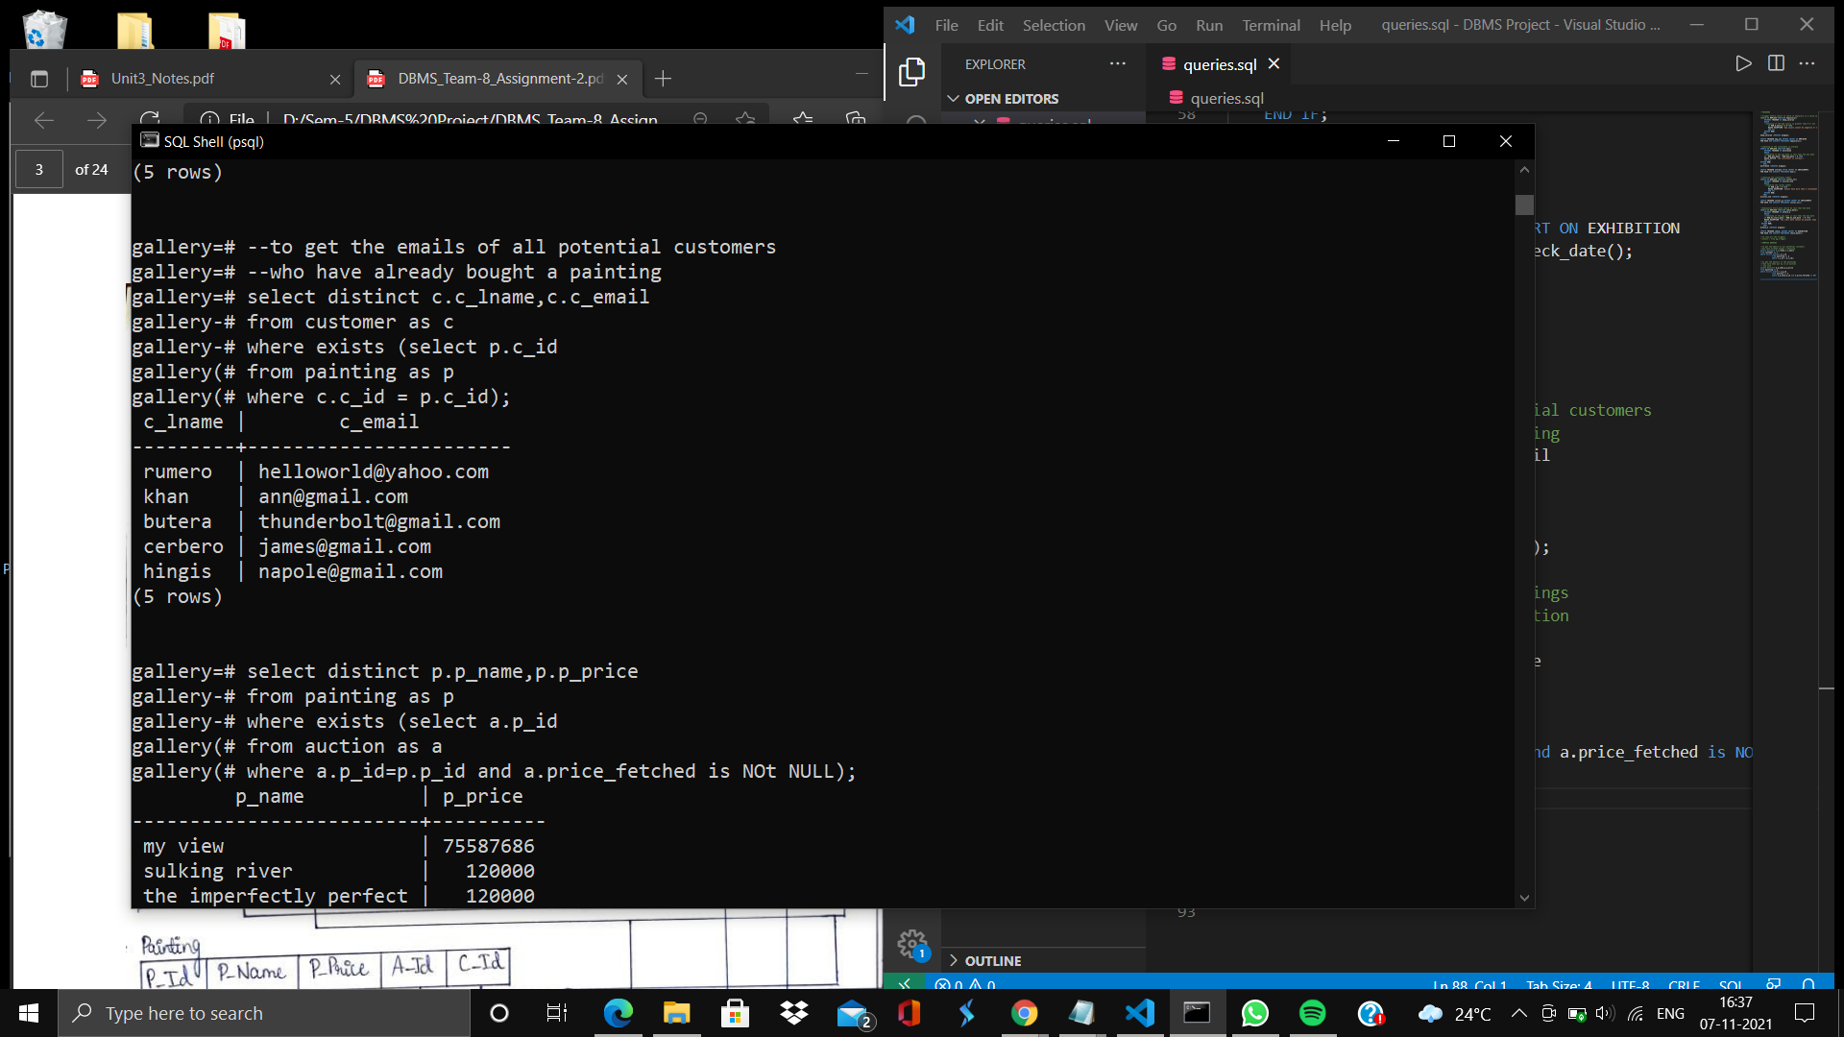

1. **To get the details of all the paintings that have been sold in auction**

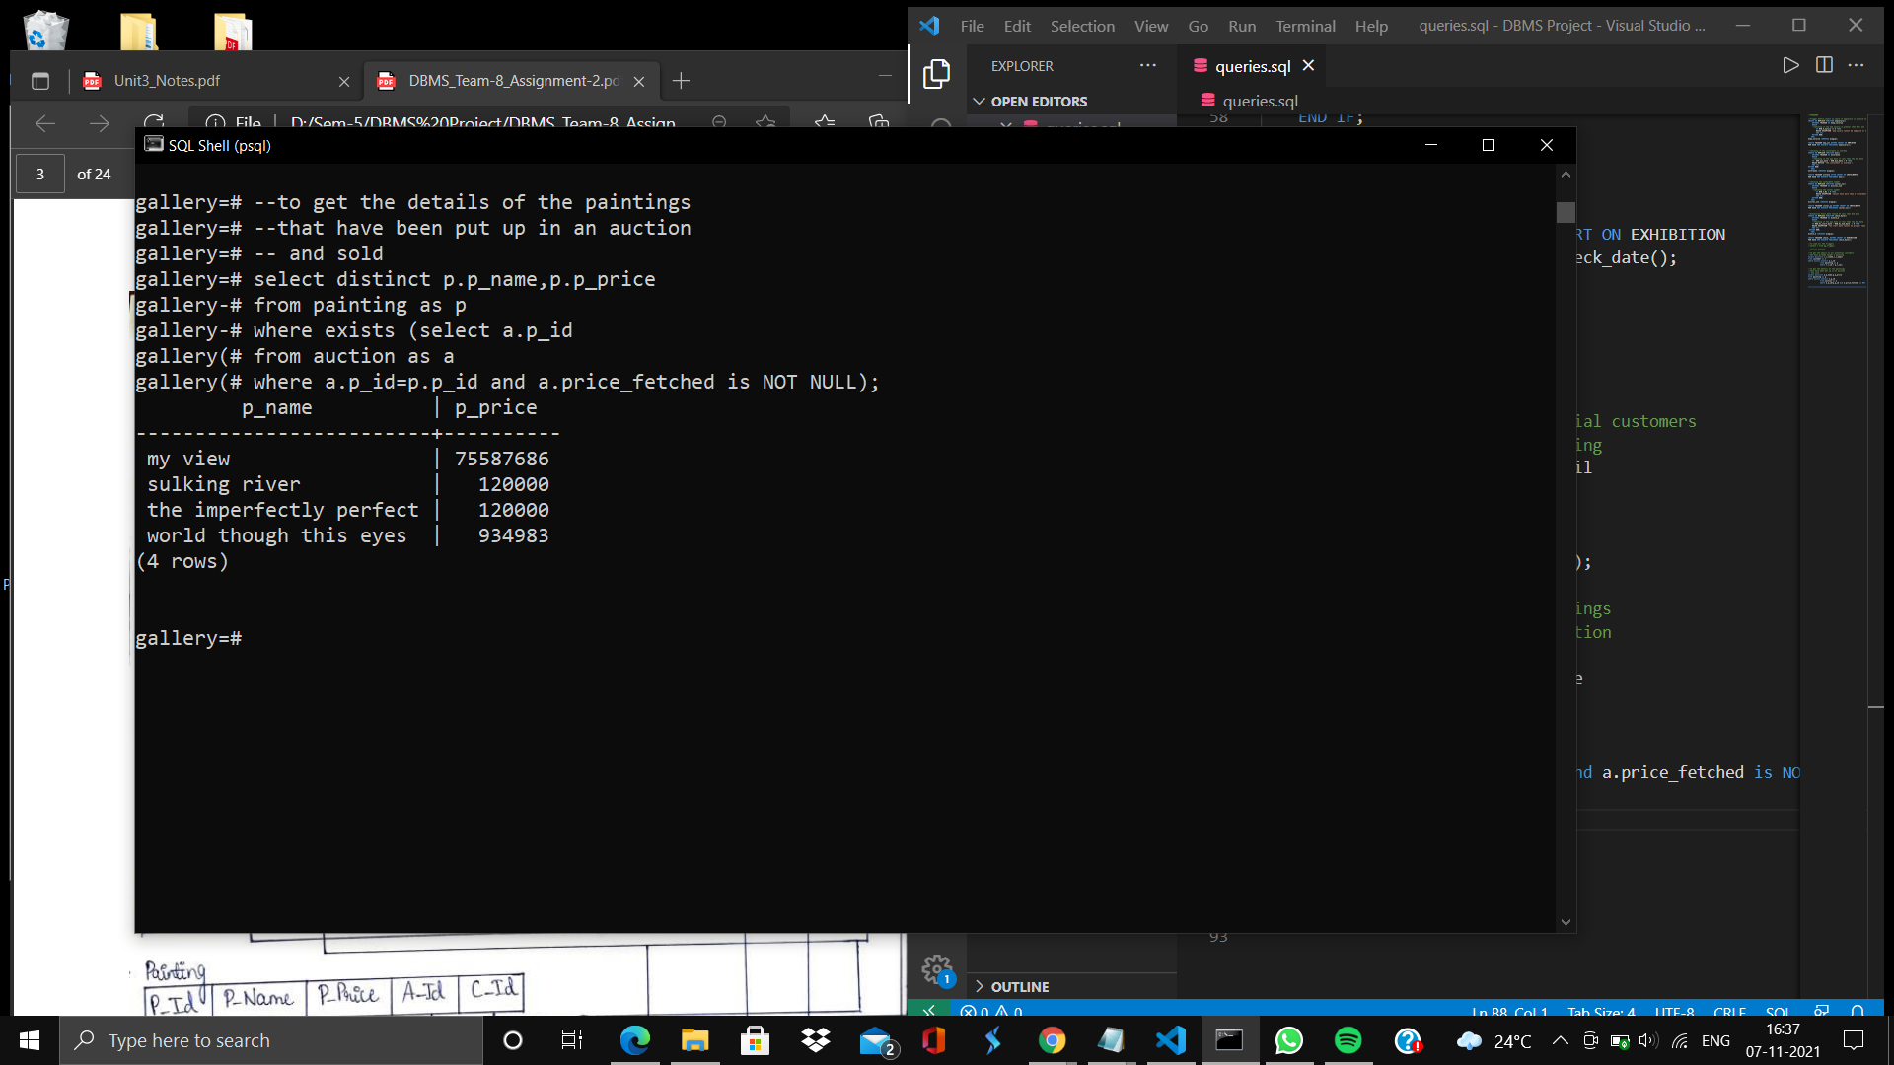

1. **To get the number of instalments and the total amount of of each customer**

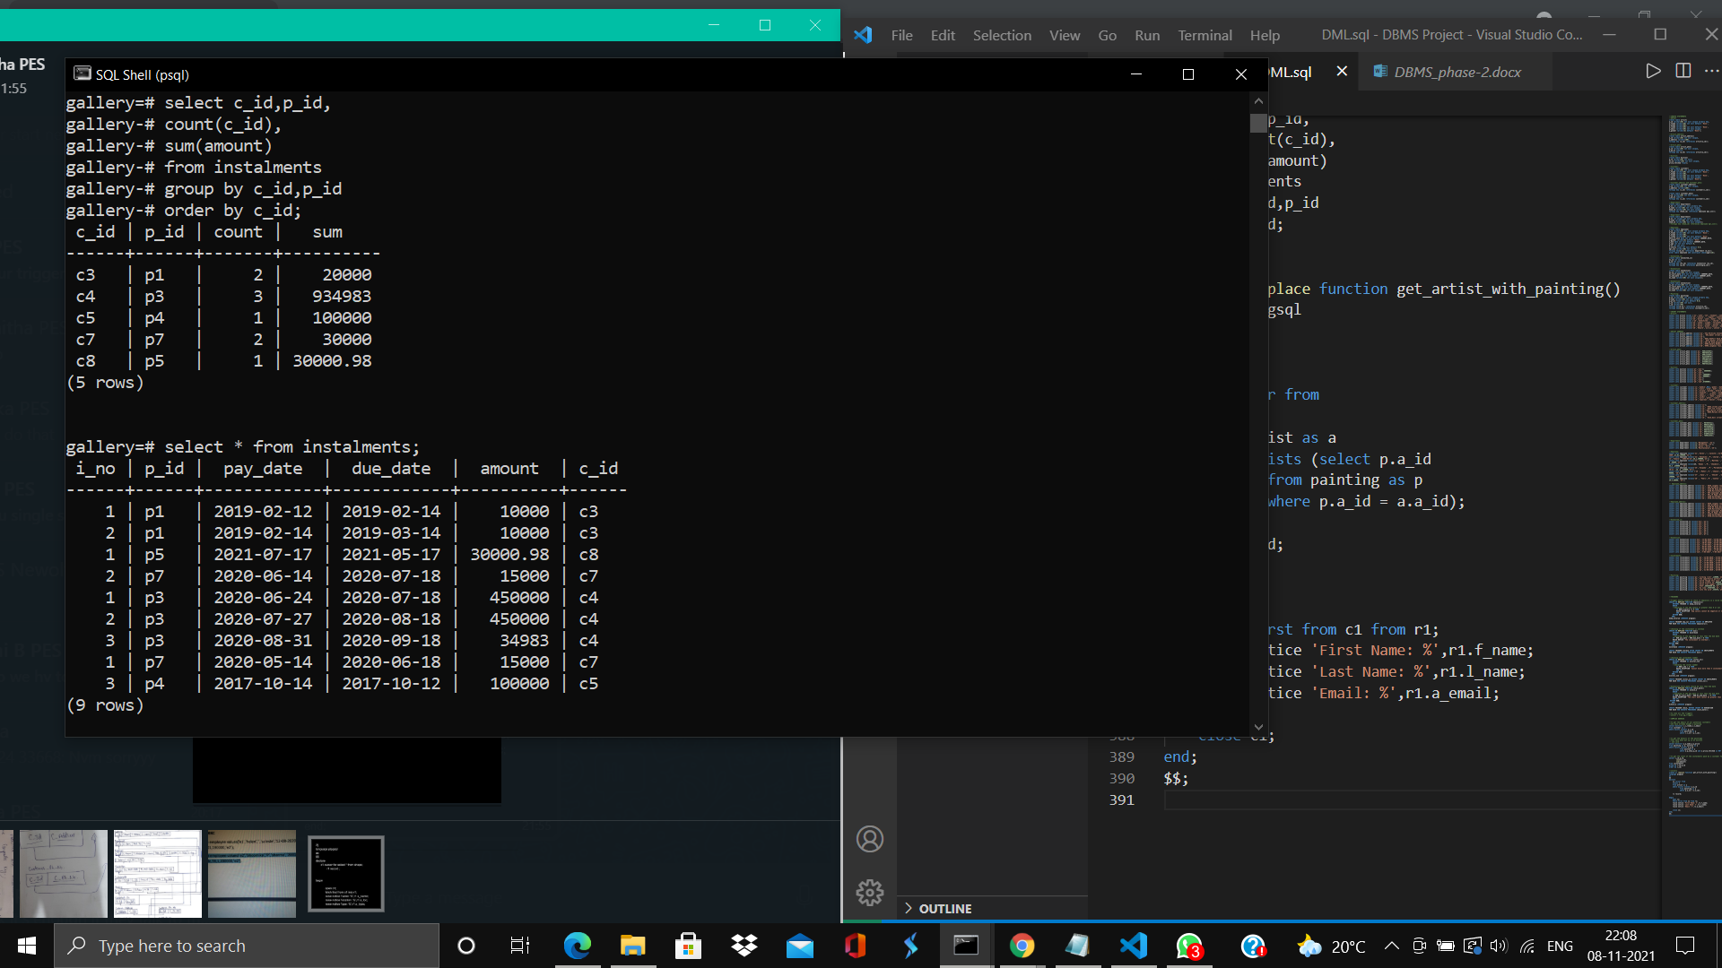

1. **To get the paintings that have been exhibited atleast once**

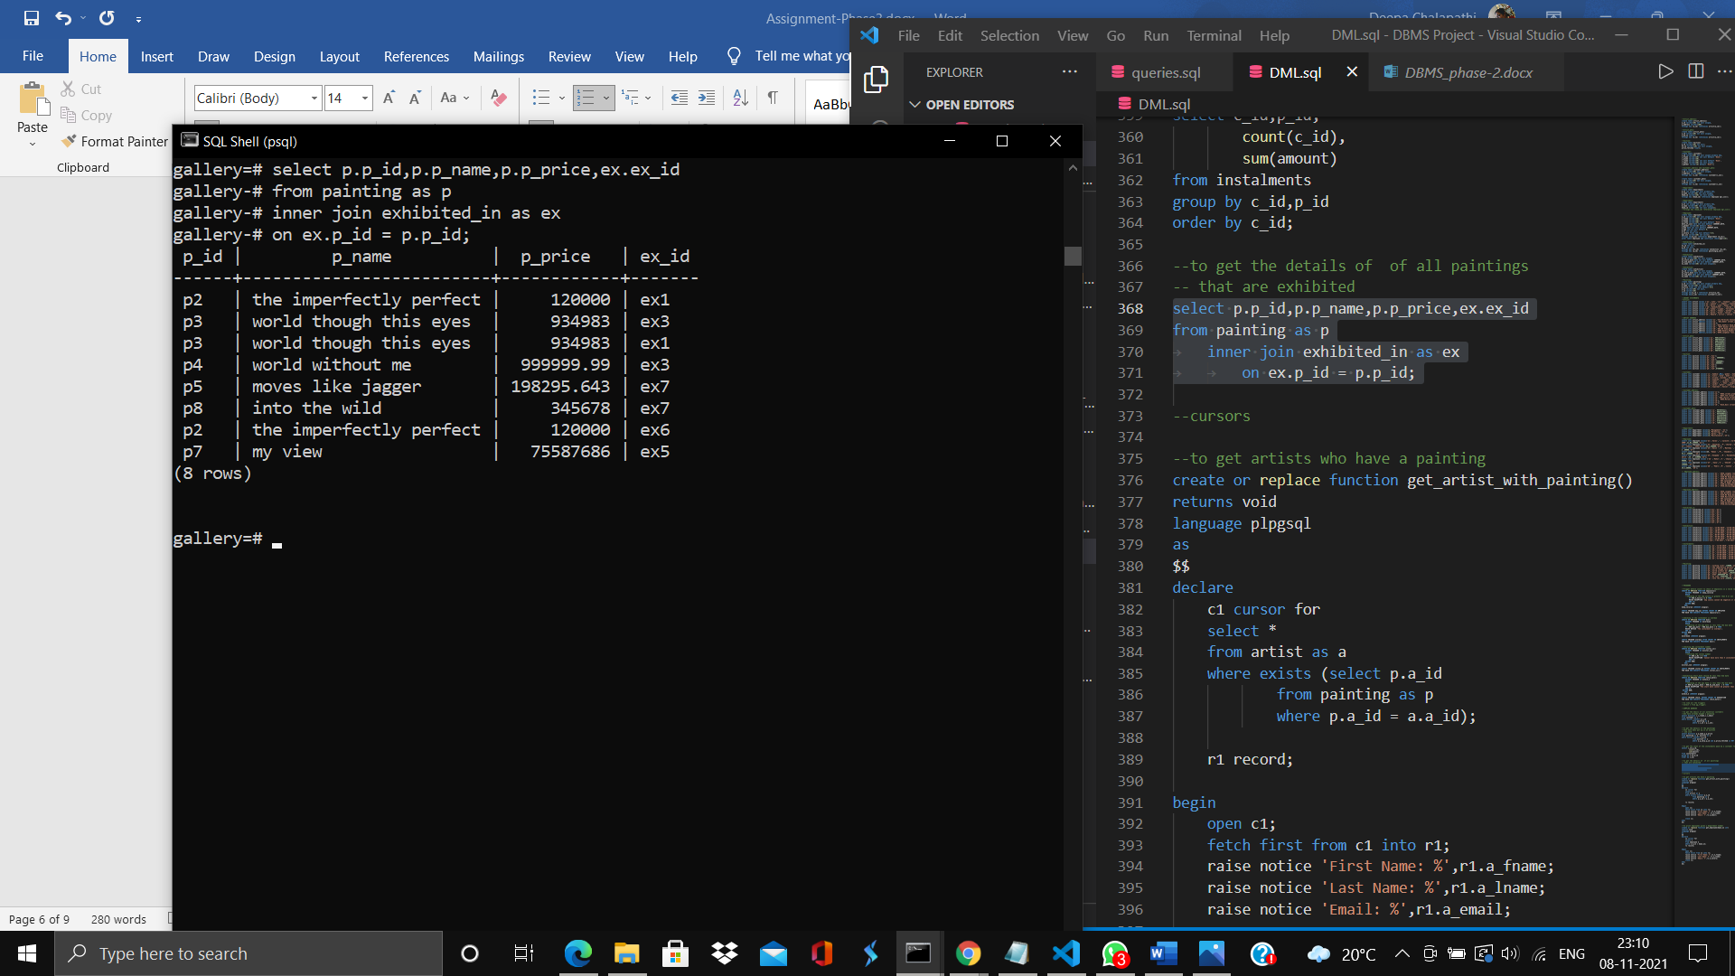

**Cursors:**

**1.To get artists with paintings in the gallery**

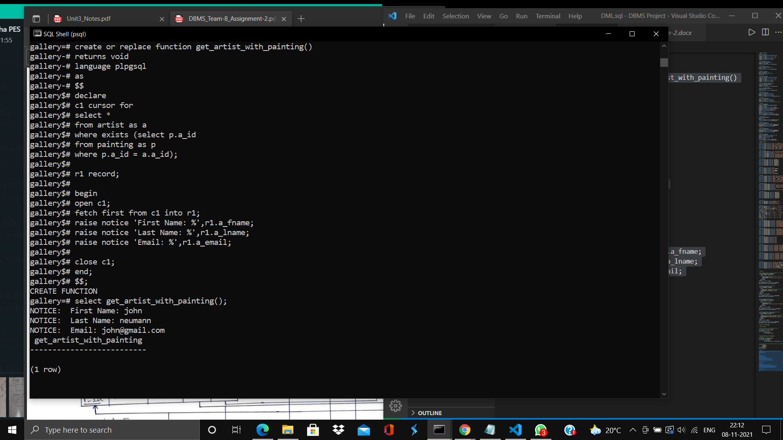

**2.To get employees from a given department number:**

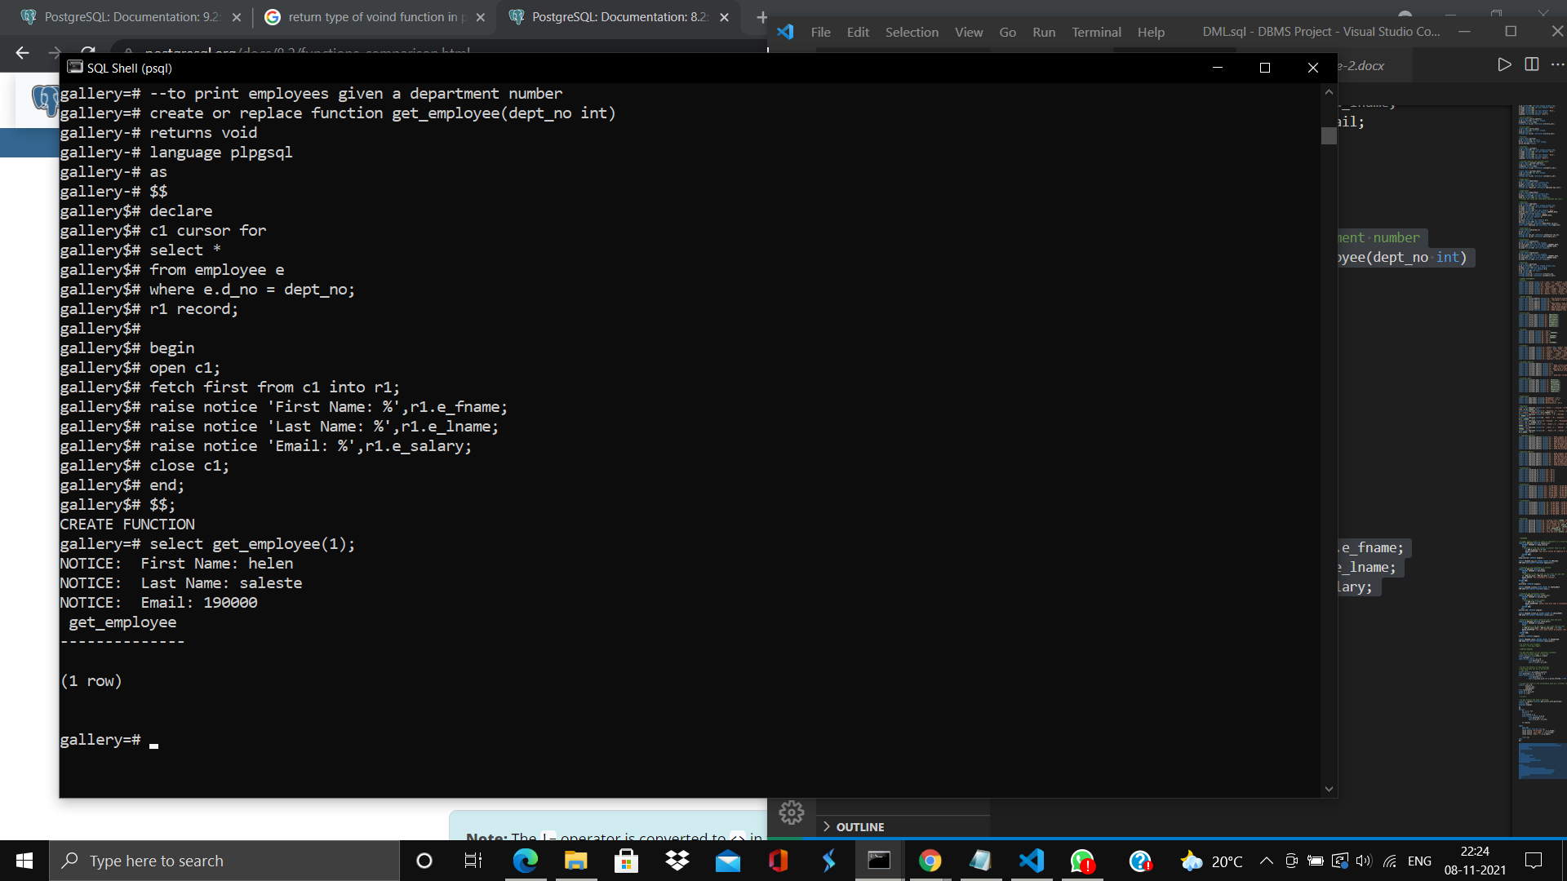

**User privileges:**

**A total of five users are created to manage the whole database.**

1. **Admin: Has all privileges on the database(Create,Connect and Temporary)**



1. **Sales manager is given select privileges on:**

**PAINTING, ARTIST, ARTIST_PHNO,ARTIST_ADDRESS, CUSTOMER, CUSTOMER_ADDRESS,CUSTOMER_PhNo**

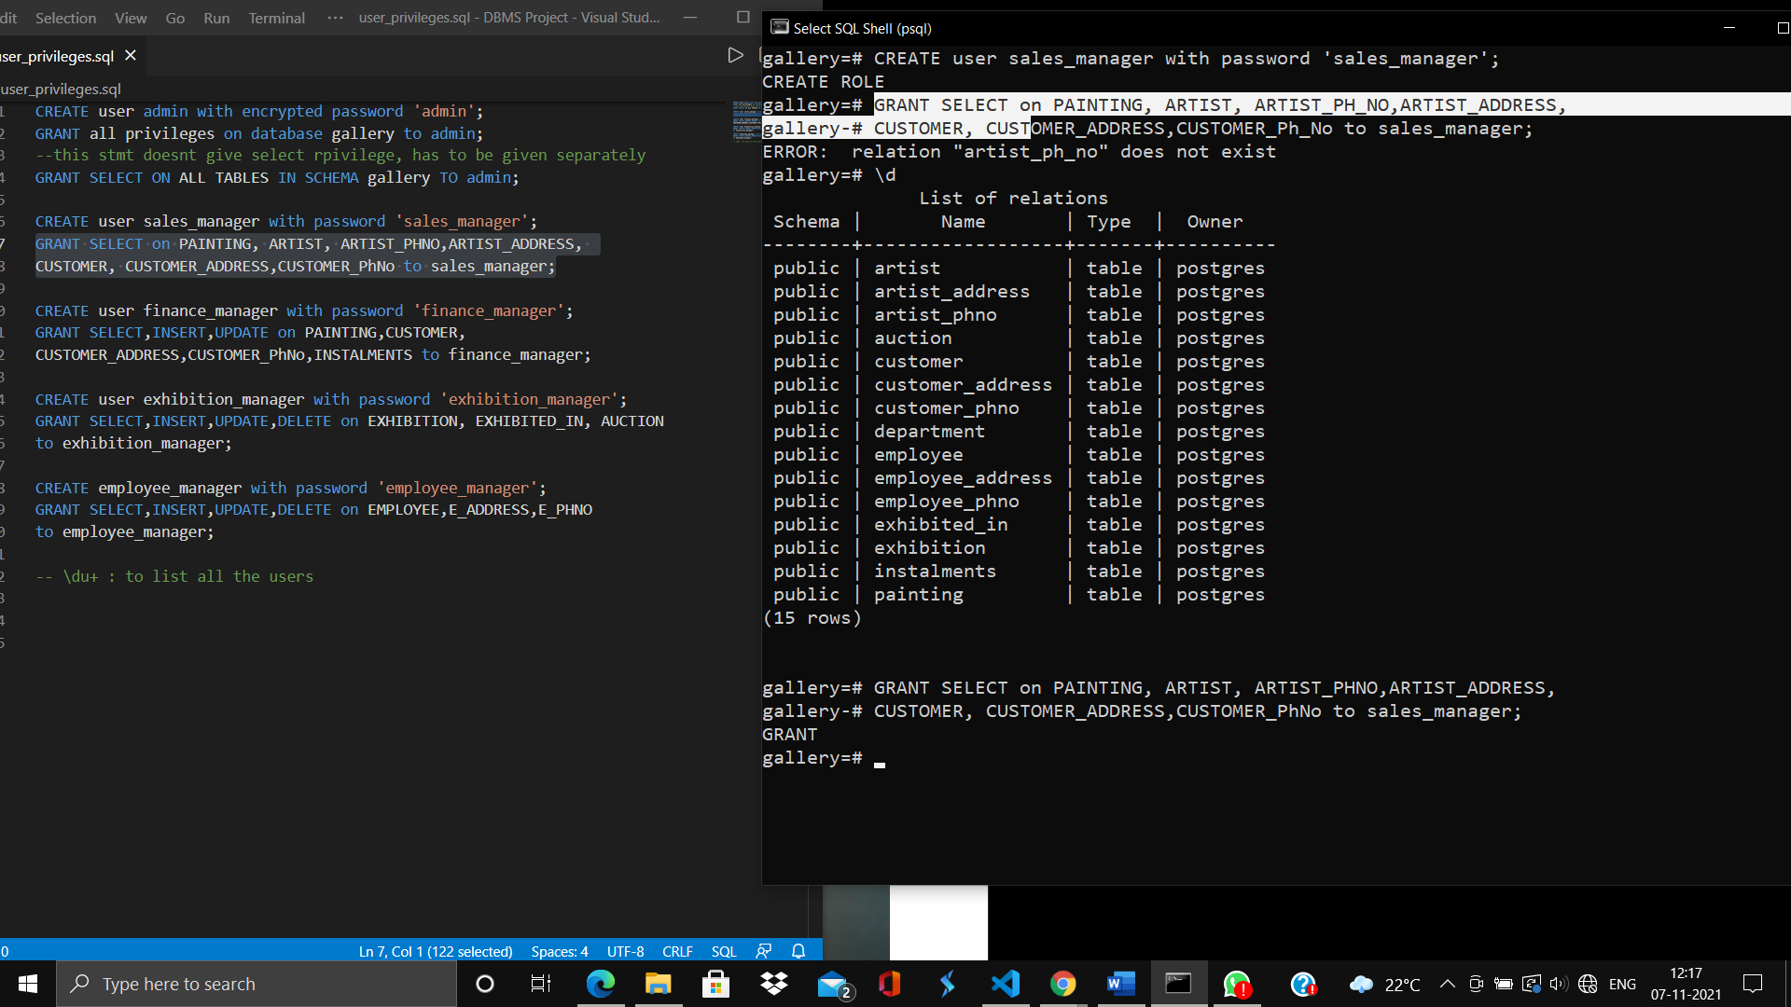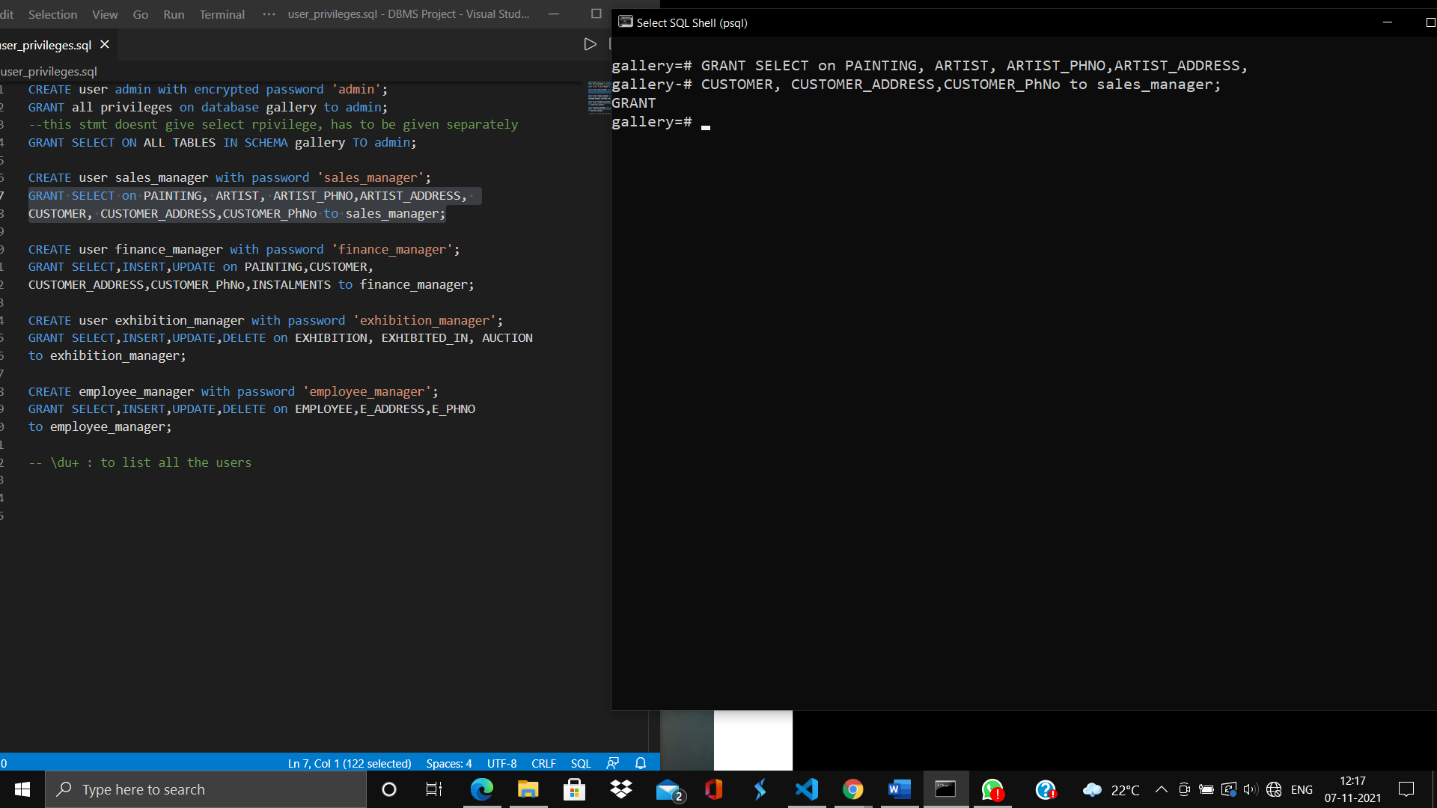

**The user can’t delete a record because only select is granted.**

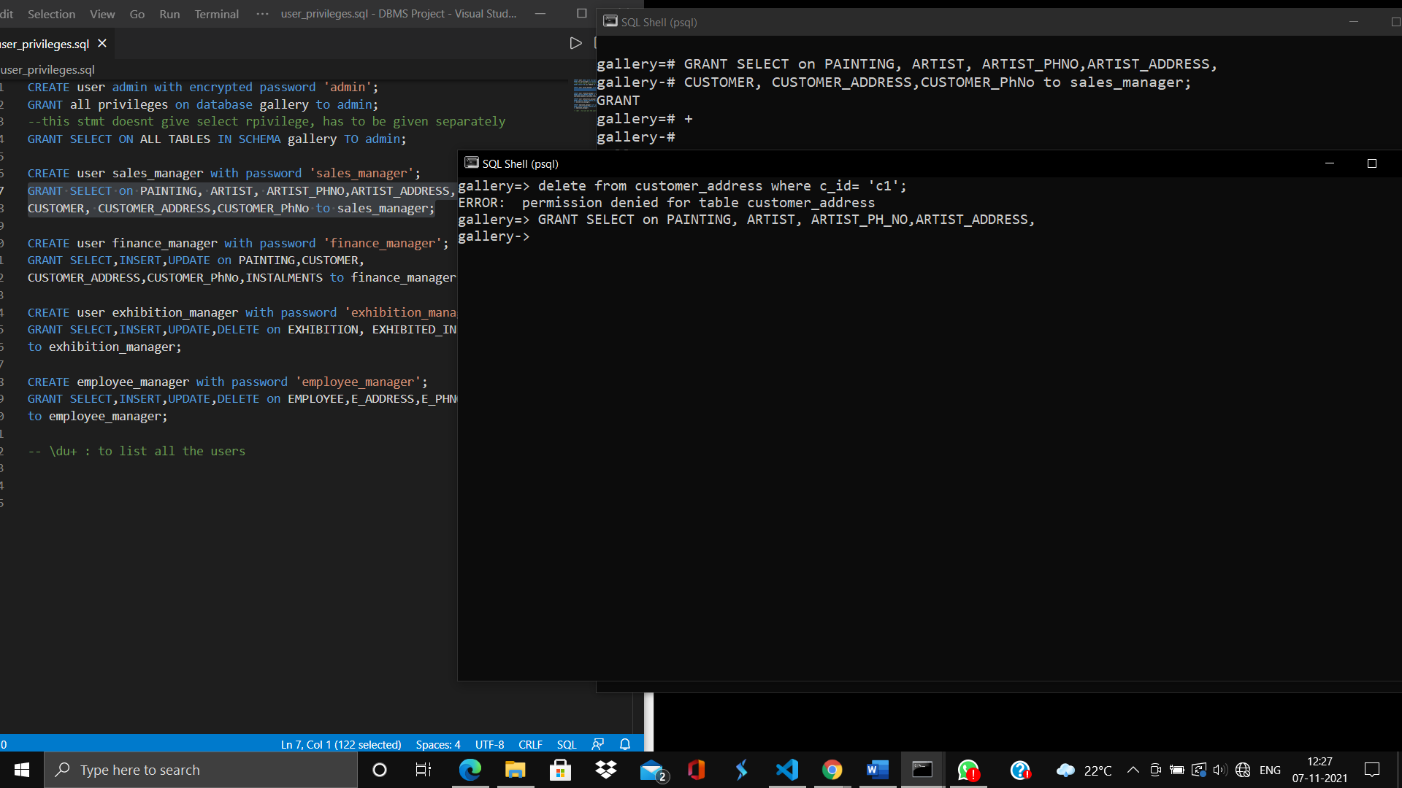

1. **Finance Manager is given SELECT, INSERT, UPDATE PRIVILEGES ON PAINTING,CUSTOMER,CUSTOMER_ADDRESS,CUSTOMER_PhNo,**

**INSTALMENTS**

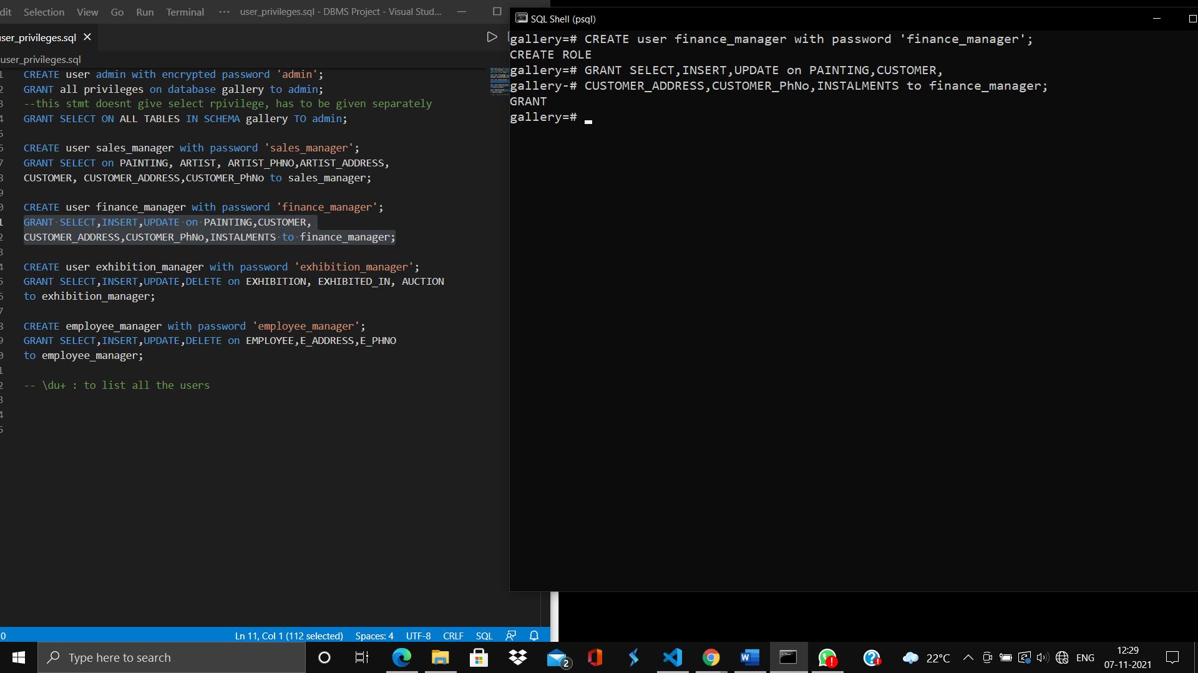

**Inserting a new value into the relation painting**

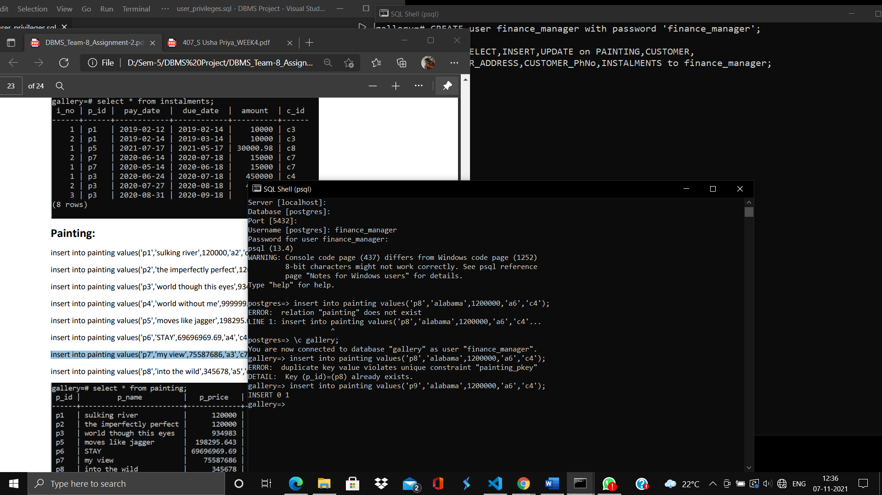

1. **Exhibition manager:**

**Has select, insert, update, delete privileges on**

**exhibition, exhibited_in, auction**

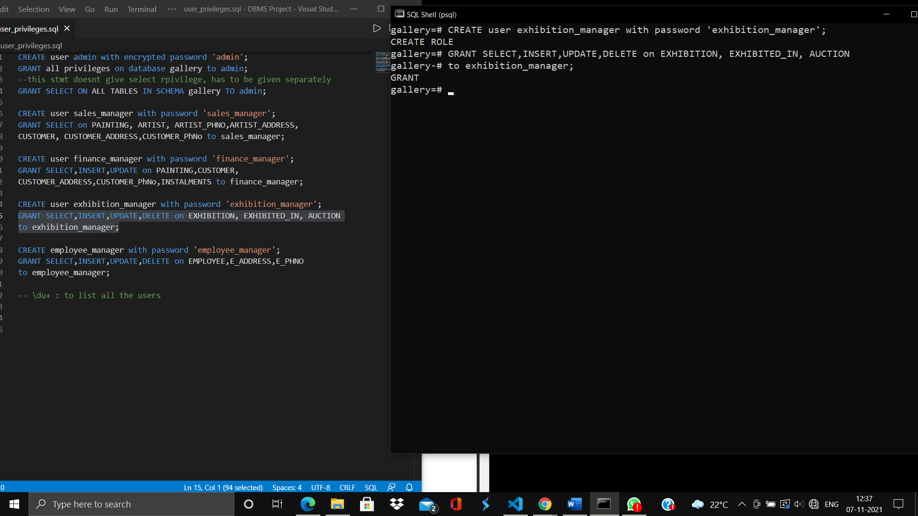

**Select * on auction by exhibition manager:**

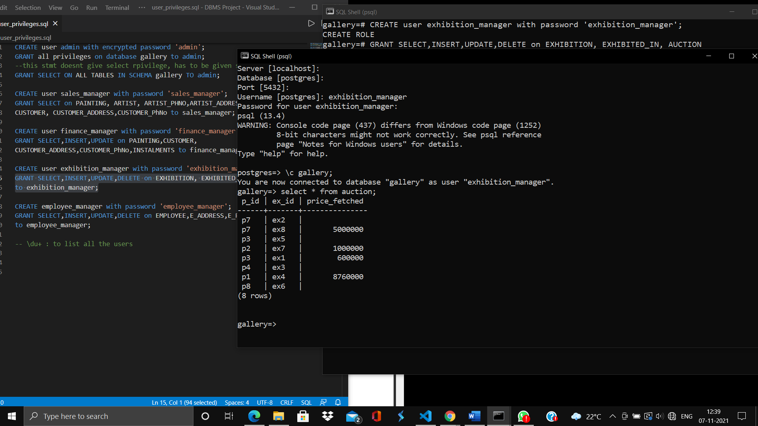

1. **Employee manager:**

**Has select, insert, update, delete privileges on:**

**EMPLOYEE,EMPLOYEE_ADDRESS,EMPLOYEE_PHNO**

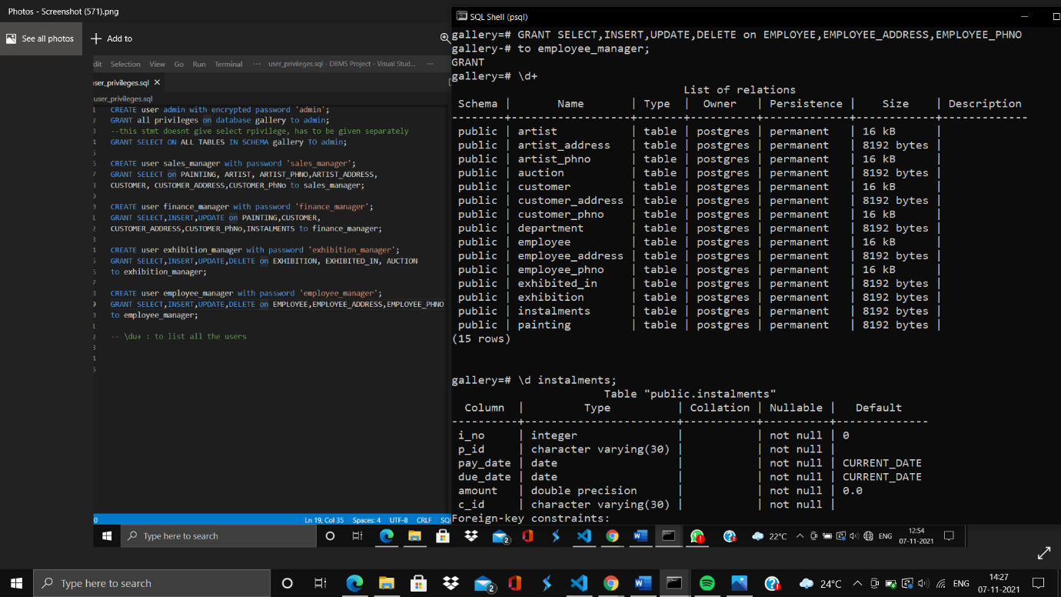

**select * from employee_phno by employee_manager:**

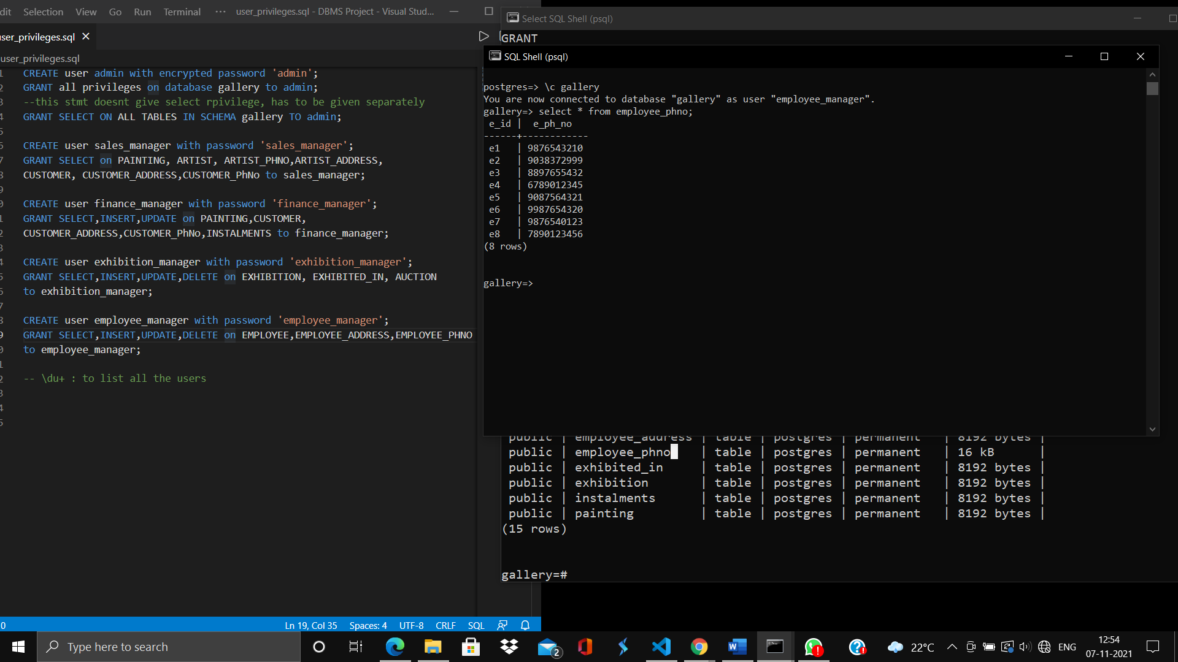

**Individual Contributions:**

**Deekshitha: 2 queries and cursors**

**Deepa: Triggers, 2 queries and user**